**Report on arm Angles prediction**

**Group 6**

| Name | ID |
| --- | --- |
| Mostafa Tarek Gaber | 94071 |
| Mohamed Ezz | 94303 |
| Abdelrahman Ahmed | 94271 |
| Nour Ehab | 94330 |
| Farah Waleed | 94082 |

**Dr**: Mohamed Badawi

**ENG**: Eslam Said

**Course**: Neural Networks (AI 446)

**Abstract**

* We used 3 models of NN using MATLAB and by changing the parameters, we found the best model accuracy is (Generalized Regression Neural Network).
* With the Python code, We used 3 models NN and 5 machine learning models, and also by changing the parameters like (activation function) and (number of hidden layers and neurons) we found that the best model accuracy in NN Models is (feed-forward sklearn) and in the Machine Models is (Decision tree regression).

**Introduction:**

* First of all, we decided to use MATLAB and Python code to get the best accuracy for our project.
* In MATLAB we used many models like (Feedforward Neural Network) & (Generalized Regression Neural Network)& (Radial Basis Function) but the (Generalized Regression Neural Network) OR (GRNN) has the best accuracy.
* With the Python code, We used 3 models of (NN) (feed-forward sklearn) & (normal neural network by TensorFlow) & (neural network with 1 conv1D).
* In the end, we found that the best model accuracy In (NN) is (feed-forward sklearn ).
* And 5 machine learning models, (Decision tree regression) & (Extreme Gradient Boosting) & (Extra LeesRegressor) & (CatBoost Regressor) & (Light Gradient Boosting Machine) In the end we found that the best model accuracy In (ML) is (Decision tree regression).

**Data Preprocessing:**

1. Separate the data into training and testing sets.
2. Training data has 4000 points, while testing data has 1000 points.
3. For Matlab, transpose each file.
4. Input Size of the Neural Network: 3
5. Output Size of the Neural Network: 6

**Matlab Models:-**

1. **Feed-Forward Neural Network**

1.1. Model Architecture

* The specific activation functions are used in the network layers.
* The type of training algorithm used (e.g., gradient descent, backpropagation).
* The size and complexity of the network (number of neurons, layers).
* The performance of the network on training and validation data.

1.2. Model fitting

* The feed-forward network was trained for 21 epochs, and it achieved a correlation coefficient of 0.98387 on the training data and 0.98223 on the validation data.
* The test data correlation coefficient is 0.9812

1.3. model hyperparameters

* Hidden Layer Size [30, 20, 10]
* Output layer trainlm used for backpropagation
* Network layers logsig, tansig, purelin
* Network regularization 0.001
* Learning Rate 0.00001
* Epochs 1000
* Batch size 16

**2. Radial Basis**

2.1. Model Architecture

* The model's target mse is 0.01.

2.2. Model fitting

* The Radial Basis network was trained for 3950 epochs and reached mse 0.051265

**3. Generalized model**

3.1. Model Architecture

* The model's target spread value is 0.01.

**Python Models:-**

**1. feed-forward sklearn:**

1.1. Model Architecture

* experimented with various activation functions and solvers

1.2. model hyperparameters

* activation 'identity', 'logistic', 'tanh', 'relu'
* optimizer 'lbfgs', 'sgd', 'adam'
* The first layer has 512 neurons, and the second layer has 256 neurons.

**2. Machine learning models**

* Different models were tested; the best was the decision tree regressor.

**Results**

To see how well it works, the graphs will only show one output.

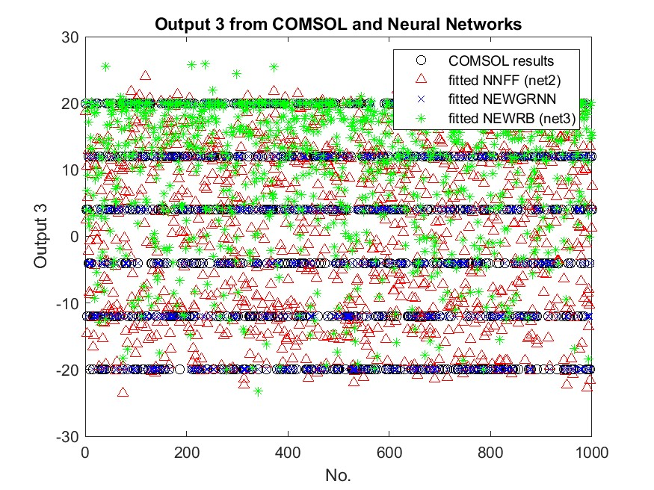

Figure 1 shows the Matlab model's prediction for output 3.

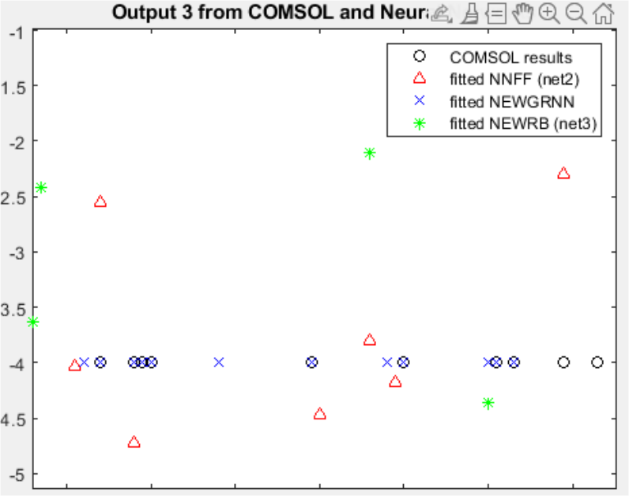

Figure 2 Zoomed one for Figure 1

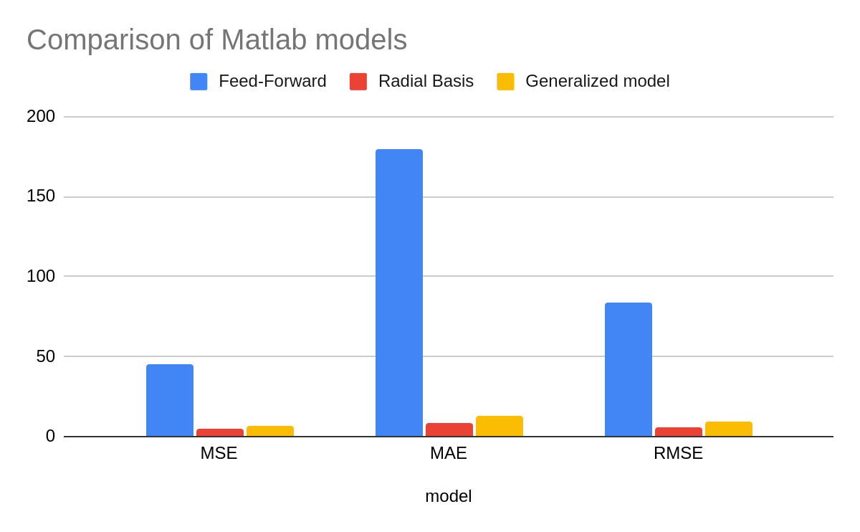Figure 3 Comparison of Matlab models

Table 1 Comparison of Python models

| **Model** | **MAE** | **MSE** | **RMSE** | **R2** | **TT (Sec)** |
| --- | --- | --- | --- | --- | --- |
| Decision Tree Regressor | 0.0053 | 0.0025 | 0.0421 | 1 | 0.019 |
| Extreme Gradient Boosting | 0.0581 | 0.0078 | 0.0878 | 1 | 0.128 |
| CatBoost Regressor | 0.0269 | 0.0014 | 0.0375 | 1 | 0.917 |
| Random Forest Regressor | 0.0312 | 0.0034 | 0.0579 | 1 | 0.216 |
| K Neighbors Regressor | 1.4344 | 3.5574 | 1.8822 | 0.9841 | 0.019 |

Generalized neural network performs best in both training and testing sets in Matlab.

Decision Tree performs best in both training and testing sets in Python.